**Pramod D Y**

**1BM19CS405**

**M L LAB REPORT**

**01). Find S algoritm**

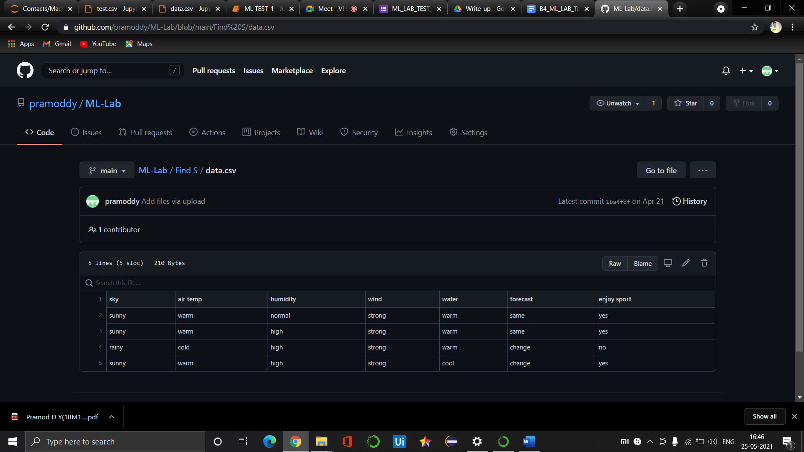

**CODE AND OUTPUT**

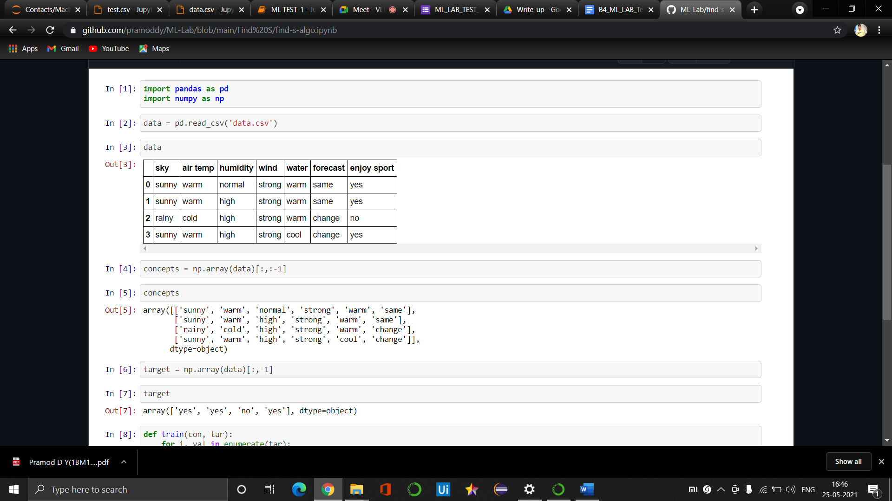

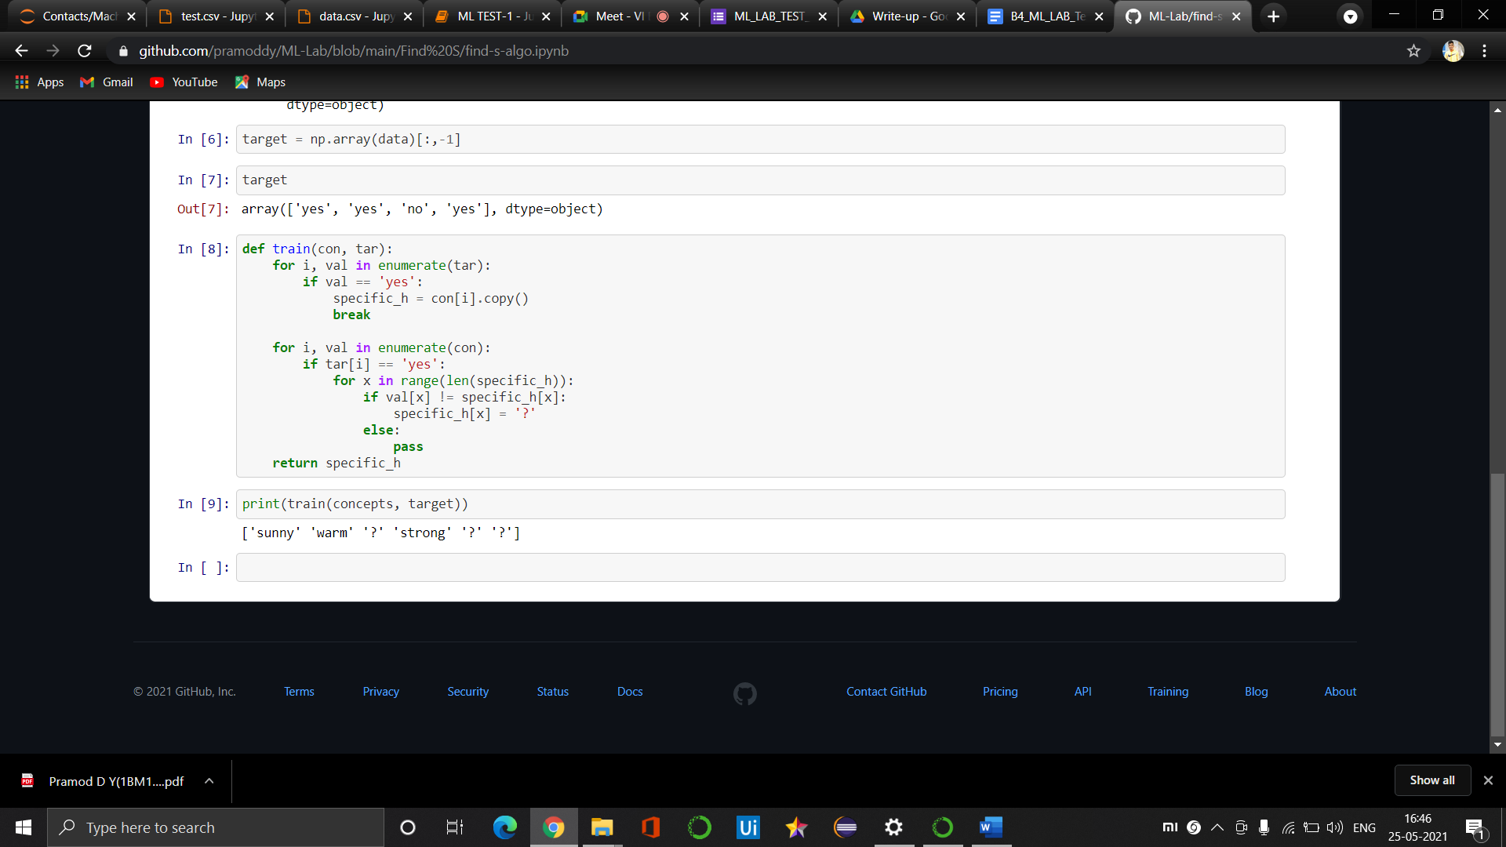

**02). Candidate Elemination algoritm**

**Data file**

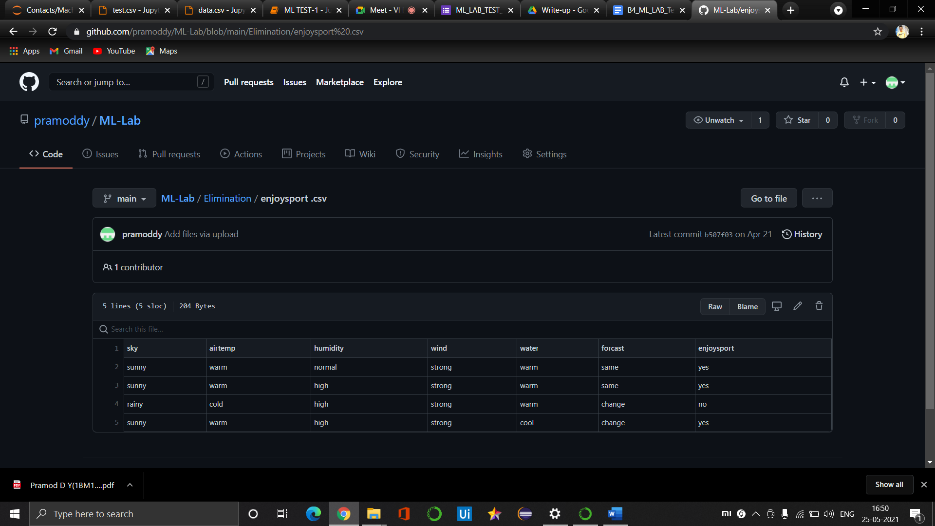

**Code and output**

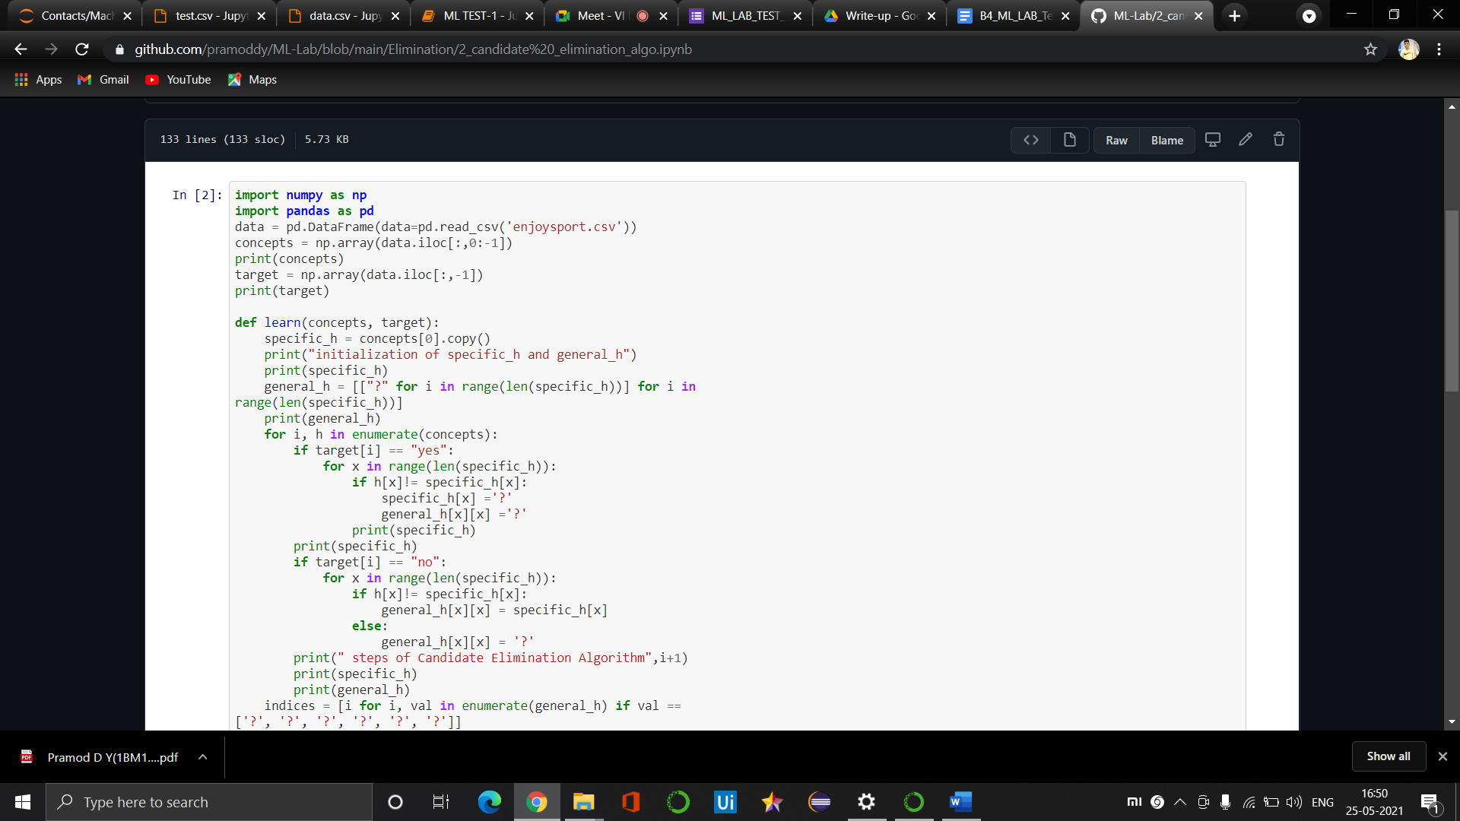

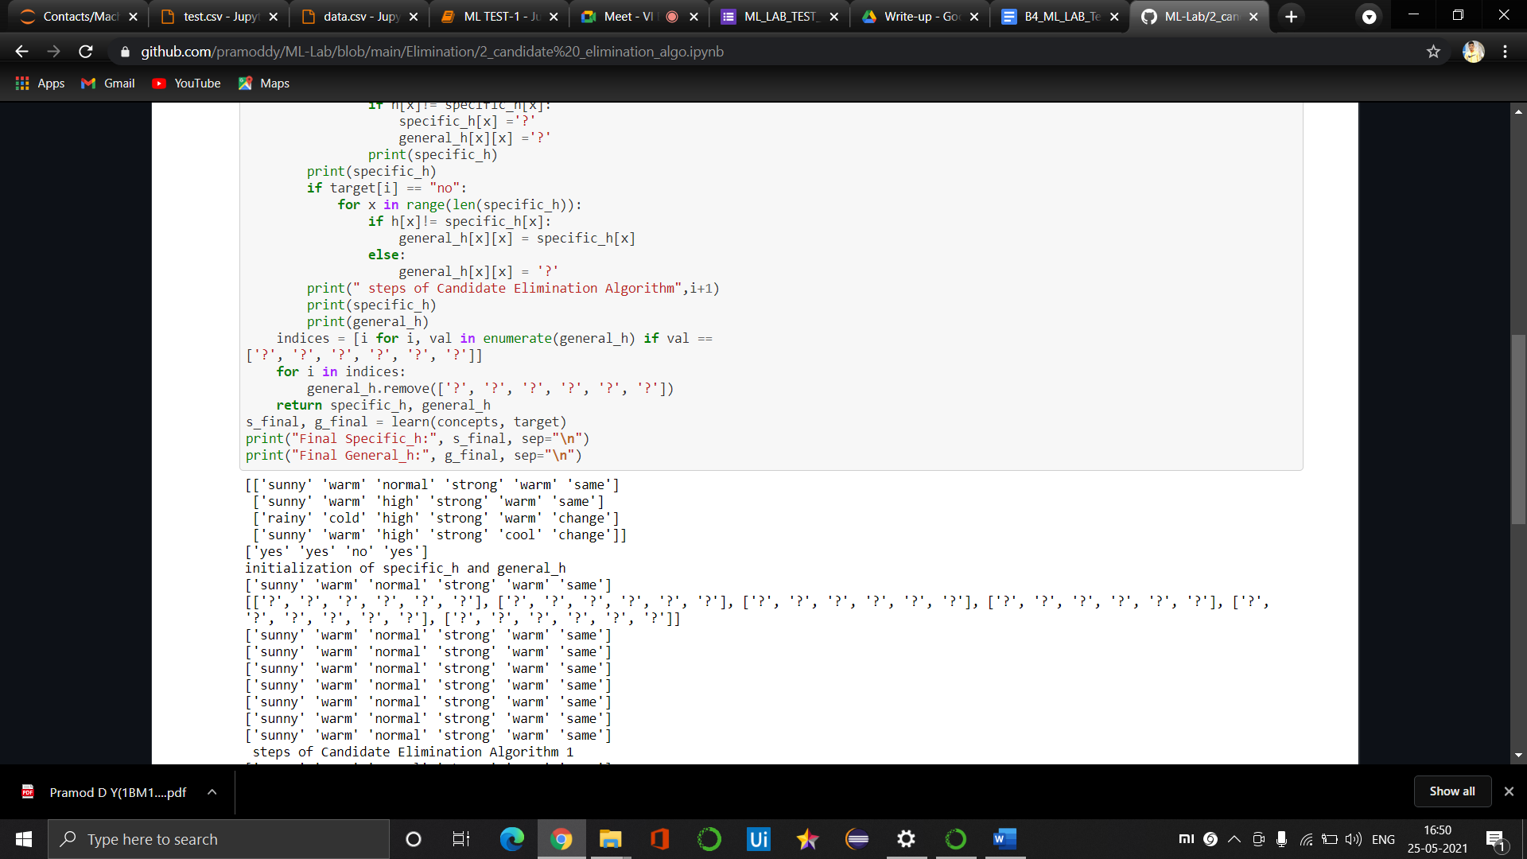

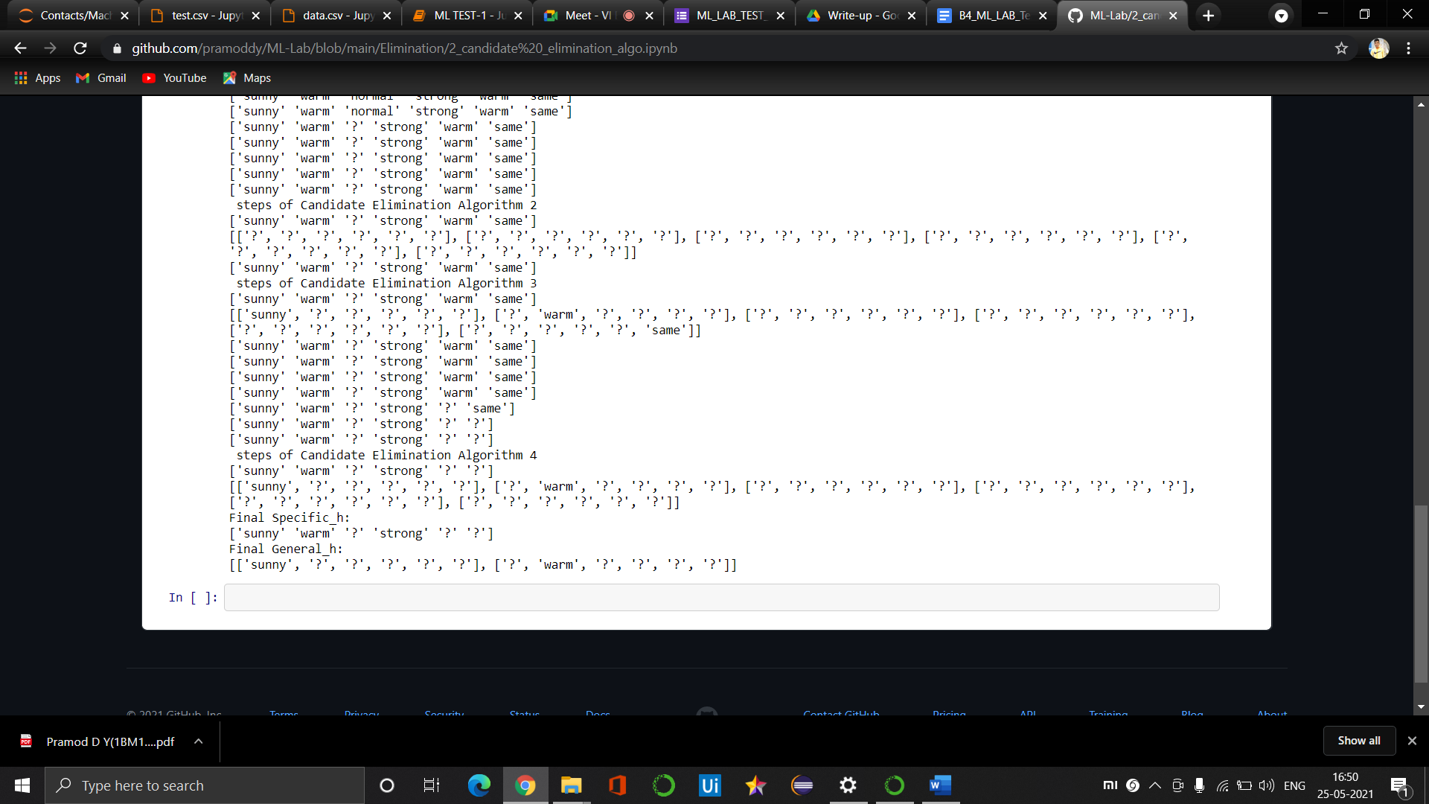

**03). ID3 progra**

**Data.csv File**

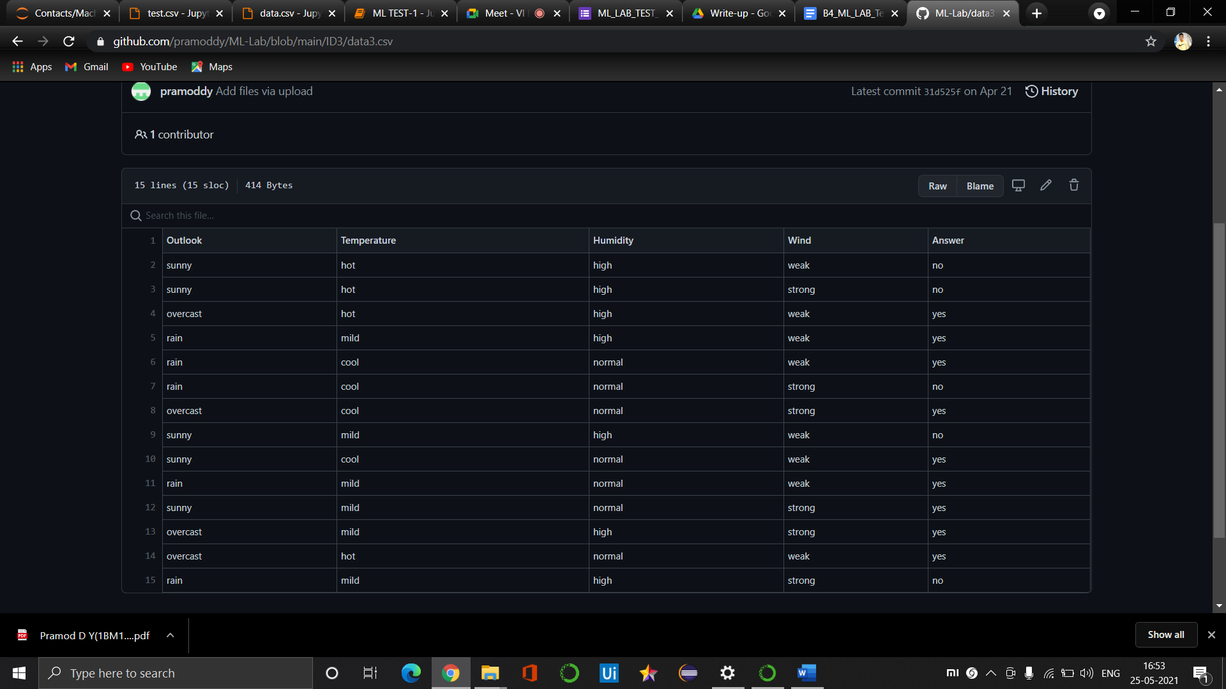

**Test.csv File**

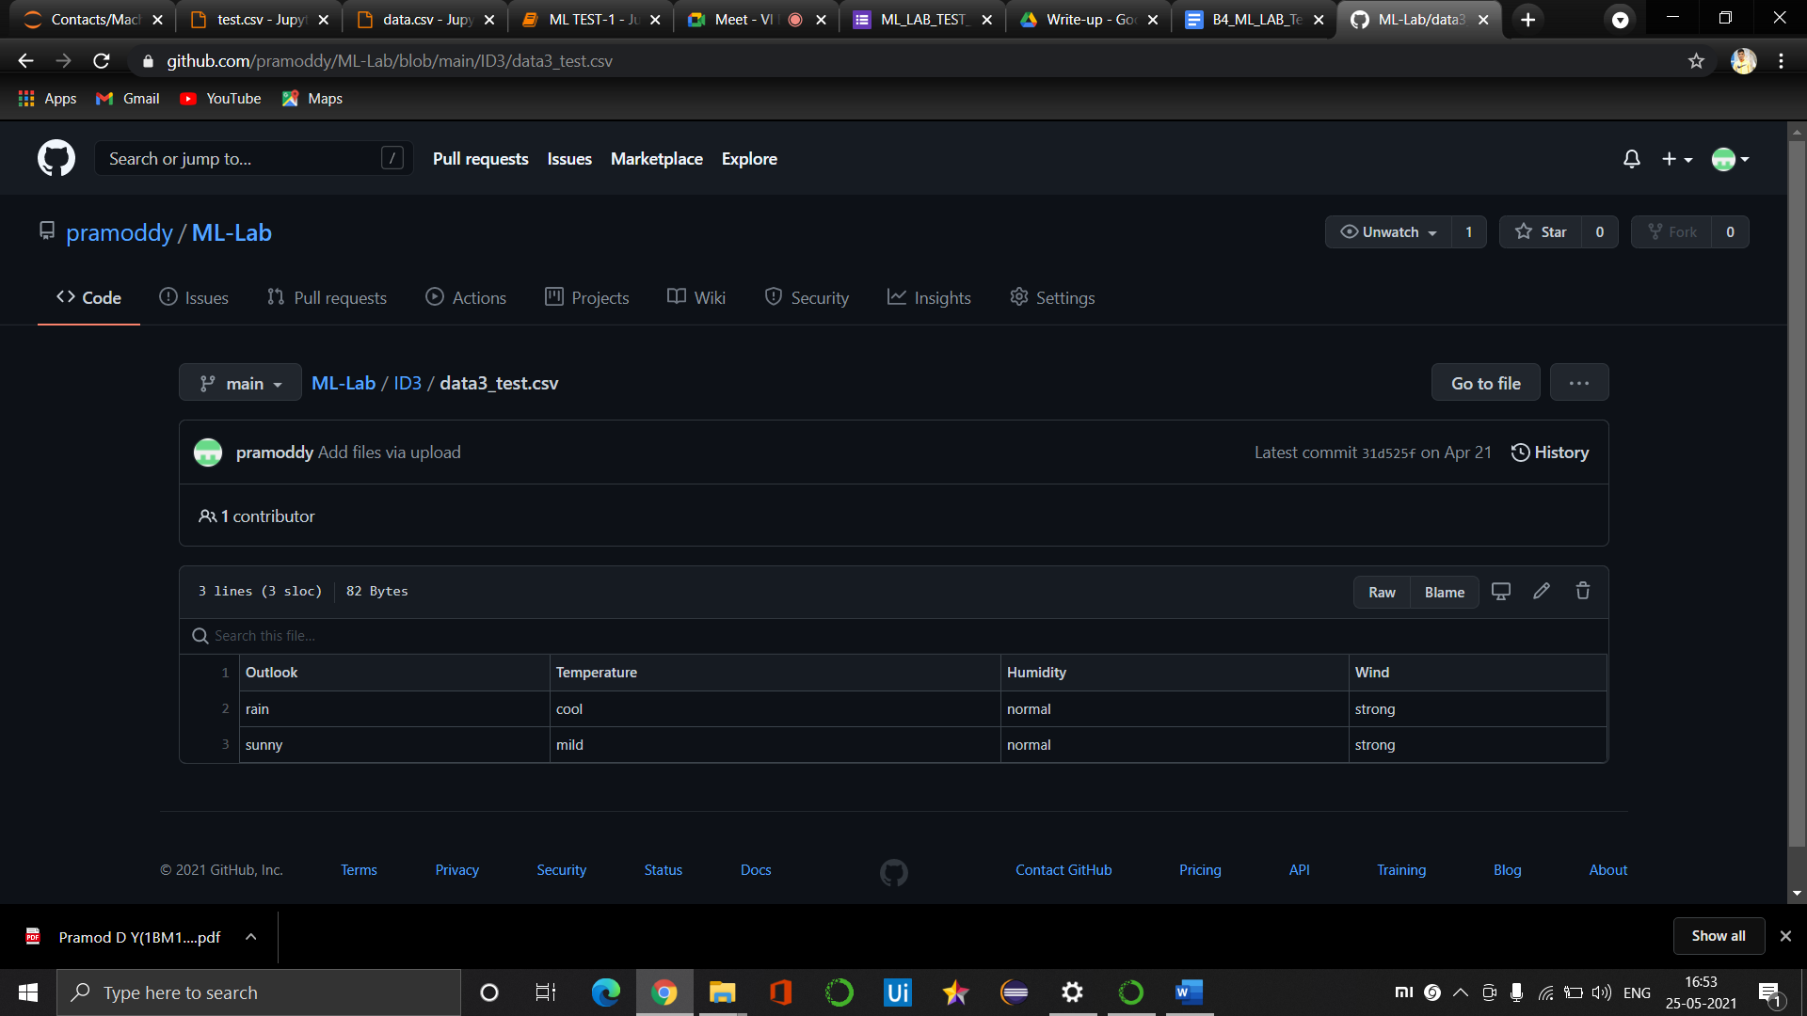

**Program :**

import math

import csv

def load_csv(filename):

lines = csv.reader(open(filename,"r"));

dataset = list(lines)

headers = dataset.pop(0)

return dataset, headers

class Node:

def __init__(self,attribute):

self.attribute = attribute

self.children = []

self.answer = ""

def subtables(data,col,delete):

dic = {}

coldata = [row[col] for row in data]

attr = list(set(coldata))

counts=[0]*len(attr)

r = len(data)

c = len(data[0])

for x in range(len(attr)):

for y in range(r):

if data[y][col] == attr[x]:

counts[x]+=1

for x in range(len(attr)):

dic[attr[x]] = [[0 for i in range(c)] for j in range(counts[x])]

pos = 0

for y in range(r):

if data[y][col] == attr[x]:

if delete:

del data[y][col]

dic[attr[x]][pos] = data[y]

pos+=1

return attr, dic

def entropy(S):

attr = list(set(S))

if len(attr) == 1:

return 0

counts = [0,0]

for i in range(2):

counts[i] = sum([1 for x in S if attr[i] == x])/(len(S)*1.0)

sums = 0

for cnt in counts:

sums+=-1*cnt*math.log(cnt,2)

return sums

def compute_gain(data,col):

attr,dic = subtables(data, col, delete = False)

total_size = len(data)

entropies = [0]*len(attr)

ratio = [0]*len(attr)

total_entropy = entropy([row[-1] for row in data])

for x in range(len(attr)):

ratio[x] = len(dic[attr[x]])/(total_size*1.0)

entropies[x] = entropy([row[-1] for row in dic[attr[x]]])

total_entropy -= ratio[x]*entropies[x]

return total_entropy

def build_tree(data, features):

lastcol = [row[-1] for row in data]

if(len(set(lastcol))) == 1:

node = Node("")

node.answer = lastcol[0]

return node

n = len(data[0])-1

gains = [0] * n

for col in range(n):

gains[col] = compute_gain(data, col)

split = gains.index(max(gains))

node = Node(features[split])

fea = features[:split]+features[split+1:]

attr, dic = subtables(data, split, delete = True)

for x in range(len(attr)):

child = build_tree(dic[attr[x]], fea)

node.children.append((attr[x], child))

return node

def print_tree(node, level):

if node.answer != "":

print(" "*level, node.answer)

return

print(" "*level, node.attribute)

for value,n in node.children:

print(" "*(level+1), value)

print_tree(n, level+2)

def classify(node, x_test, features):

if node.answer != "":

print(node.answer)

return

pos = features.index(node.attribute)

for value, n in node.children:

if x_test[pos] == value:

classify(n, x_test, features)

'''Main Program'''

dataset, features = load_csv("data.csv")

model = build_tree(dataset, features)

print("The decision tree for the dataset using ID3 algorithm is")

print_tree(model, 0)

testdata, features = load_csv("test.csv")

for xtest in testdata:

print("The test instance: ", xtest)

print("The label for test instance: ", end = " ")

**OUTPUT**

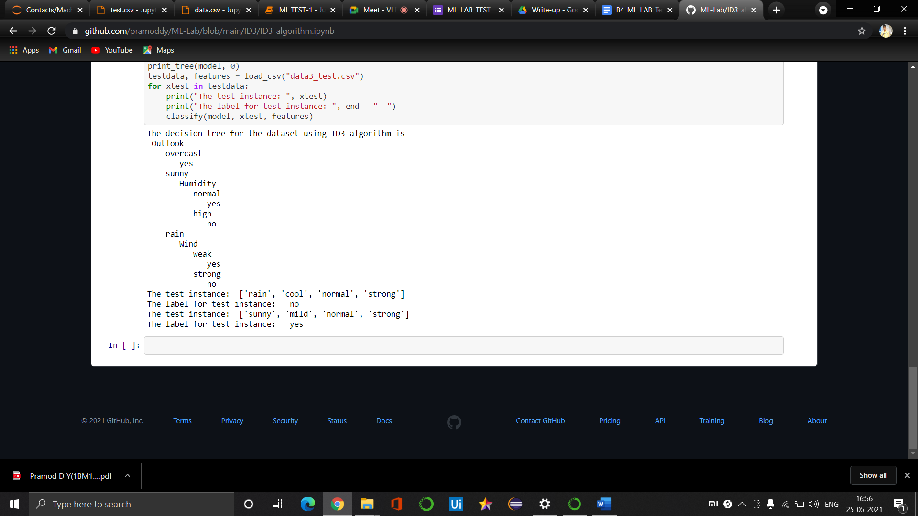

**04)navie Bayesian clasification**

**Csv file**

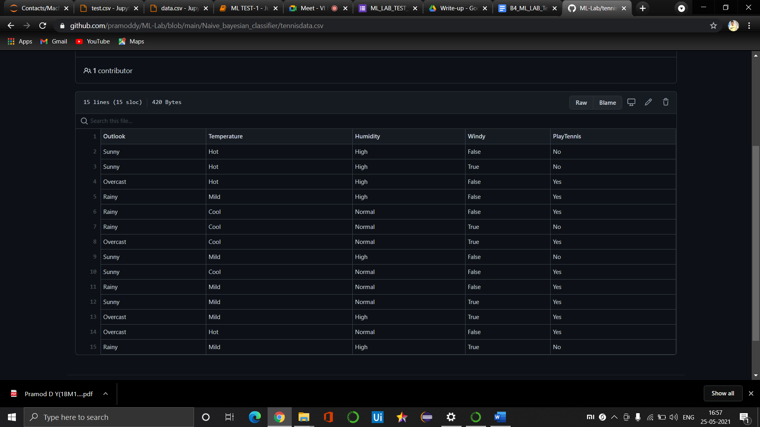

**Code an Output :**

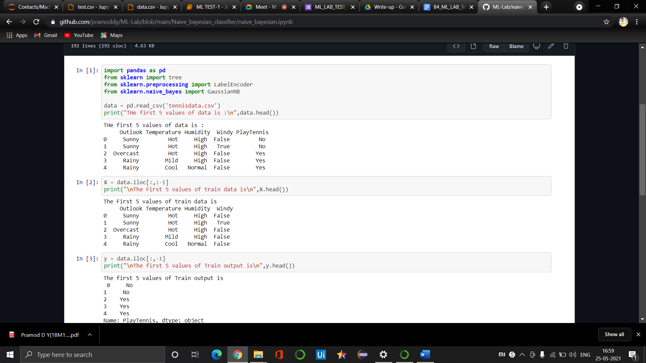

**`**

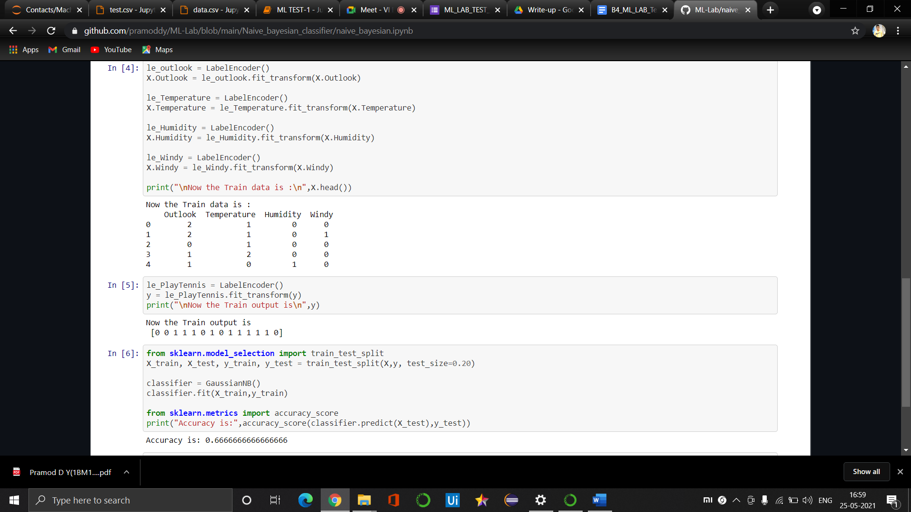

**05). Bayesian classification**

**CSV files**



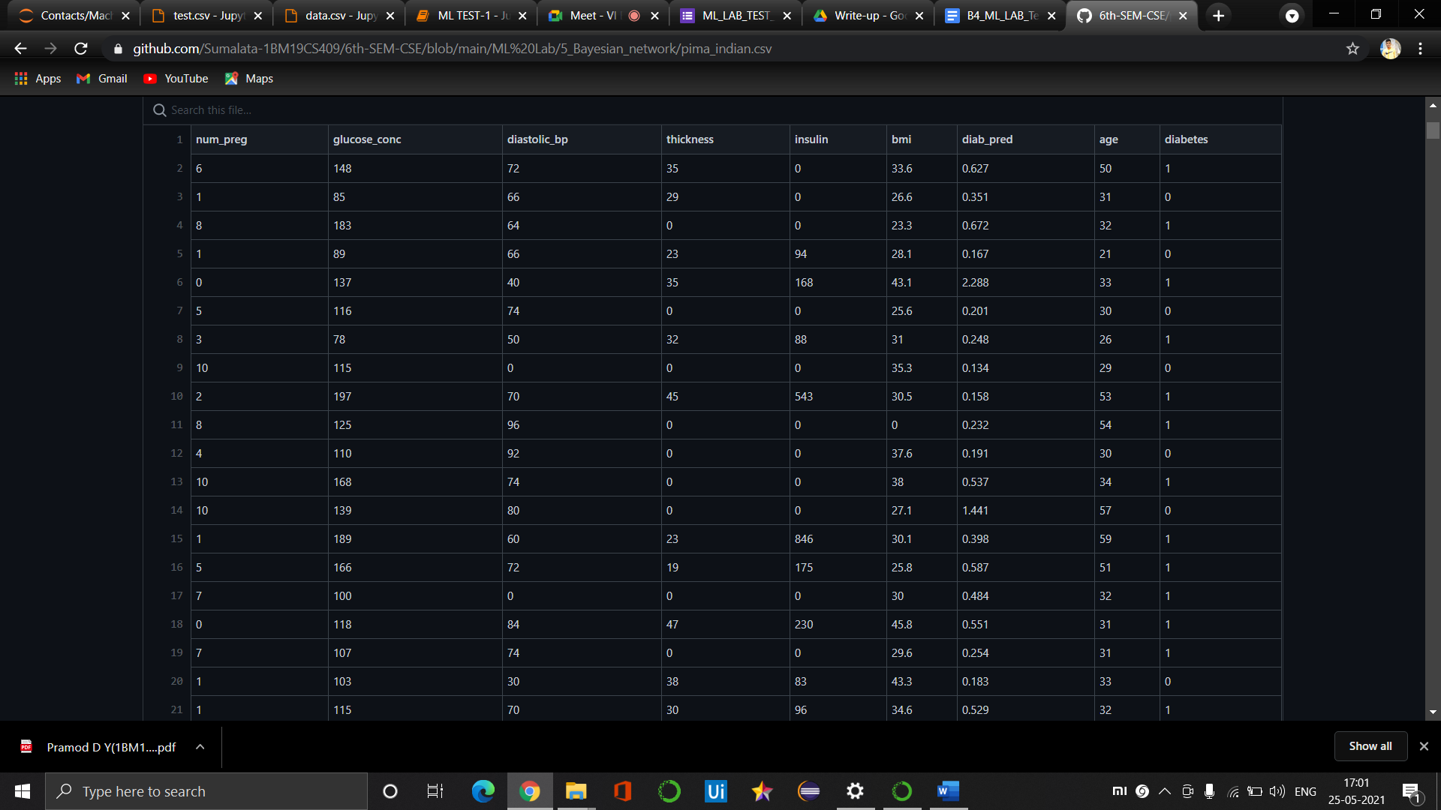

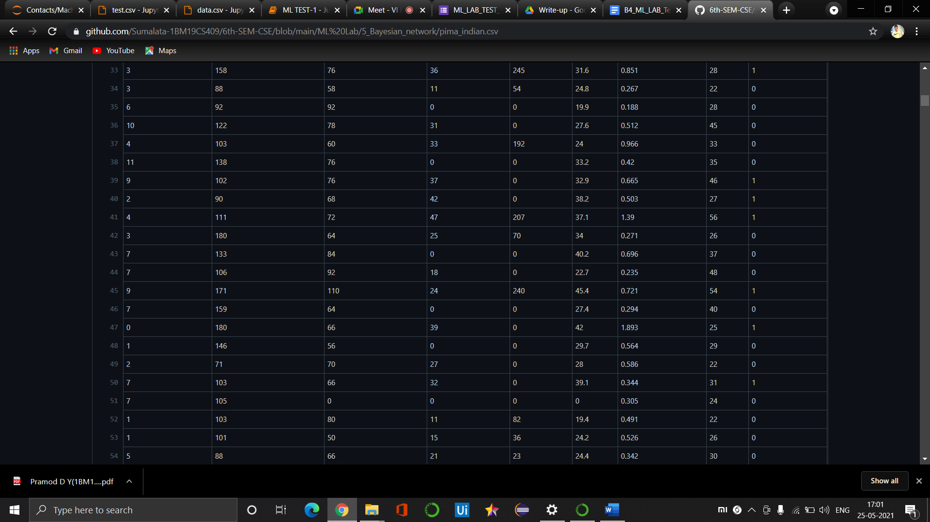

Code/Output

